**AWS Serverless**

* To work with AWS Serverless on the developer system, AWS has the tools <https://aws.amazon.com/serverless/getting-started/?serverless.sort-by=item.additionalFields.createdDate&serverless.sort-order=desc#Developer_tools>
* Ensure AWS Toolkit for vscode is also installed
* <https://aws.amazon.com/eclipse/> for eclipse toolkit and <https://aws.amazon.com/intellij/> for intellij

**Invoking Lambda functions**

* From aws events <https://docs.aws.amazon.com/cli/latest/reference/events/put-rule.html>
* <https://docs.aws.amazon.com/lambda/latest/dg/API_Invoke.html> for the AWS lambda invoke api

**Amazon API Gateway**

* This is an another component from serverless tools from AWS and it is used to create and manage RESTful and WebSocket API’s infront of your backend

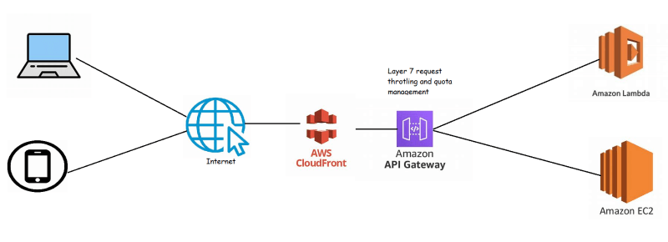

<https://aws.amazon.com/api-gateway/pricing/> for the pricing